Lab Report 02
Example1: Find the factorial of 5
Solution :
>>x=2:5;
>>prod(x)
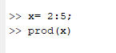
Example2: if x = [1,5,7,9,13,20,6,7,8], then

- replace the first five elements of vector x with its maximum value.
- reshape this vector into a 3 x 3 matrix.

solution :

a)
>> x(1:5)=max(x)

b)
>> y(1,:)=x(1:3);
>> y(2,:)=x(4:6);
>> y(3,:)=x(7:9);
>> y
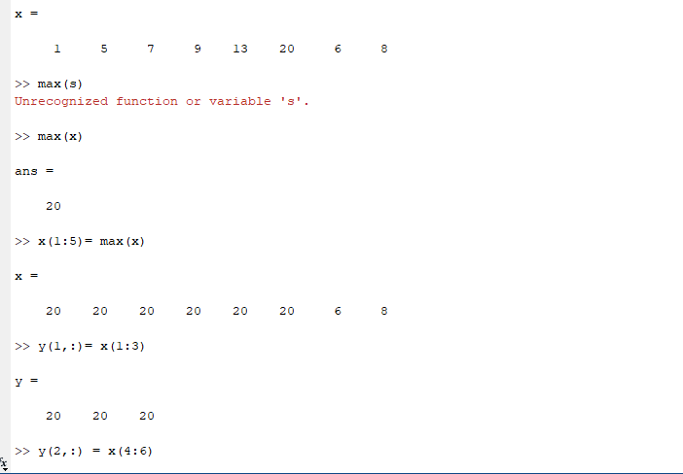
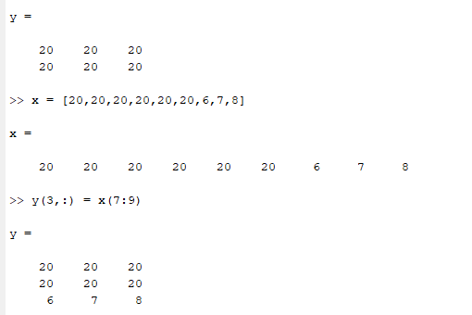

Example3: Generate the following row vector b=[1, 2, 3, 4, 5, . . . . . . . . . 9,10], then transpose it to column vector.

solution :

>> b=1:10
b =
1 2 3 4 5 6 7 8 9 10
>> b=b';
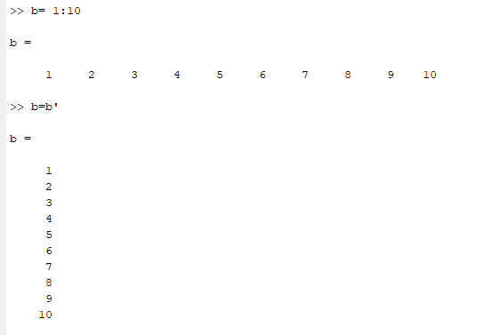

Exercise -1
1-
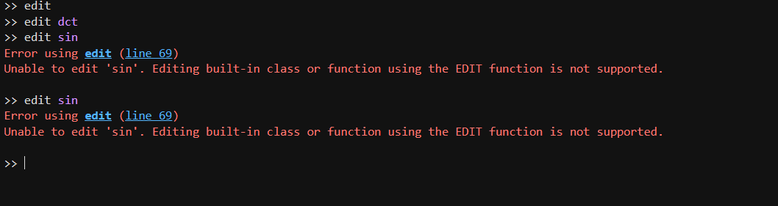
Dct is implemented as as an m file ,while sin is a built in compiled function .

2-
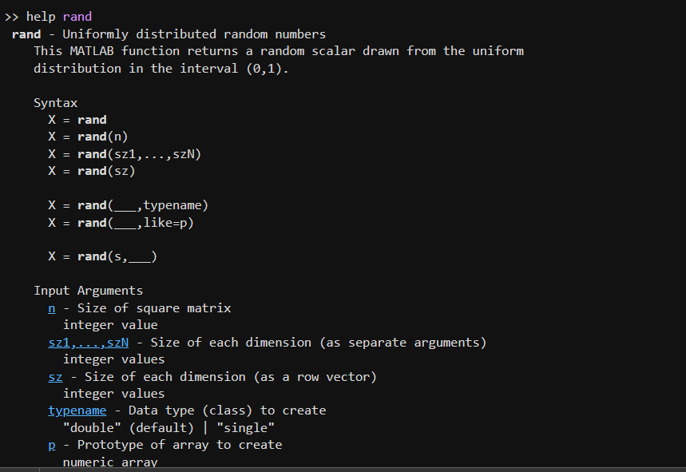

3-
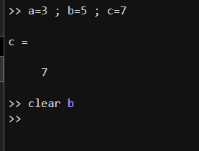

Exercise -2 :
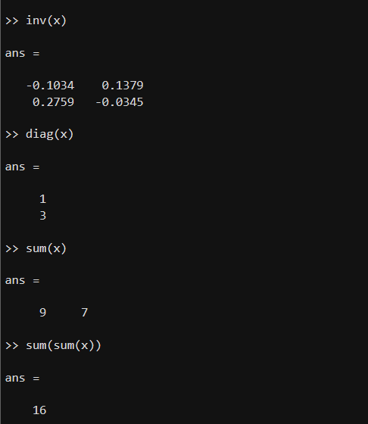
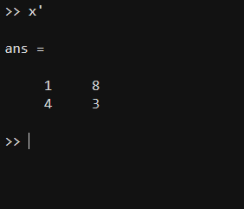
5-
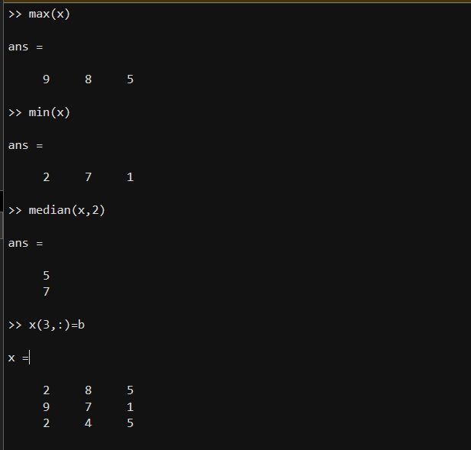

6-
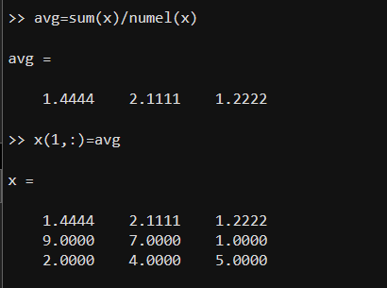
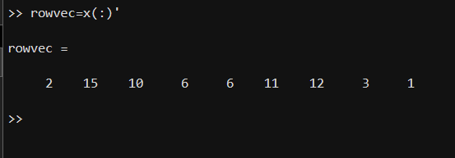

7-
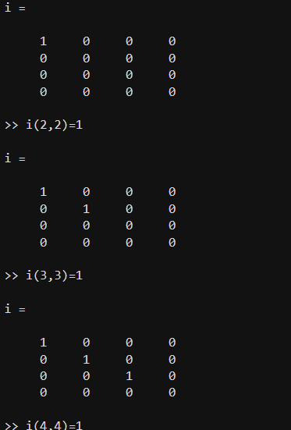

8-
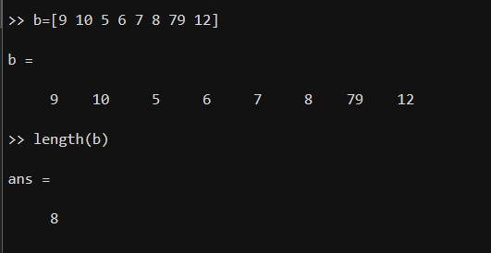
Exercise -3:
